1. **REVISION HISTORY**

|  |  |  |  |  |  |
| --- | --- | --- | --- | --- | --- |
| Rev. No. | Nature of Change | Issue Date | Originator | Reviewed by | Approved by |
| 00 | * Initial issue | March 31,2022 | **Engr. John Wevin A. Tingas**  Administrative Officer- Designate | **Engr. Pierre Anthony D. Joven**  City Agriculturist | **Engr. Ronnie Vicente C. Lagnada**  City Mayor |

1. **OVERVIEW**
   1. **Policy**

The Operations Manual (OM) of the City Agriculturists Office is established, documented, maintained, and continually improved to help improve development of the agriculture sector of Butuan City relative to its strategic objectives of ensuring a food security for the people of Butuan City and agro-industrial development in order to play a significant role in the socio-economic development of Caraga region, and also a presentation to the Relevant Interested Parties as identified by the department.

* 1. **Purpose**

This operations manual intends to serve as a guidebook for how this office functions. It displays the standard procedures on how the office operates and provide services. It demonstrates an effective way of communicating the office vision and mission and appropriate standard operating procedures for achieving the office’s goals and objectives.

* 1. **Scope**

The scope of the operations manual of by this office starts from receipt of work orders from customers including all other processes involved until the delivery of the finished goods to the respective requisitioners.

* 1. **Table Of Contents**

|  |  |
| --- | --- |
| **SECTIONS** | **PAGE NUMBER** |
| 1. Revision History | X |
| 1. Overview of the Manual | X |
| 1. Introduction to the Organization | X |
| 1. Definition of Terms | X |
| 1. Organizational Structure and Functional Descriptions | X |
| 1. Quality Management and Improvement Plan | X |
| 1. Core Processes and Policies | X |
| 1. Implementation of the Manual | X |

1. **INTRODUCTION TO THE ORGANIZATION**
   1. **Overview and History of the Organization**
   2. **Vision**

“A great hub city of opportunities for all that spurs and supports Caraga's sustainable growth and development”.

* 1. **Mission**

“A driver and catalyst towards a dynamic agriculture and fishery sector which attains food security, self-sufficiency and global competitiveness propelled by organized and empowered stakeholders”.

* 1. **Shared Core Values**
     1. Credibility – We conduct ourselves with uncompromising integrity and honesty as individuals, as teams, and as a department. We strive to earn enduring credibility with others, which we believe is essential to long-term relationships with our partners and stakeholders.
     2. Innovative – we are motivated to take actions , to take risks, encourage curiosity and new ideas, learn from mistakes, and constantly strive to exceed expectations. Being innovative, we generate solutions for our customers and raise the bar — both within our workplace and throughout the agricultural sector community.
     3. Teamwork - The strength of our team does not only lie in our combined experience and expertise but our ability to trust each other, no matter what the circumstances. We know that our best work is not produced by individuals but by enjoying collaboration as a team and supporting each other every day.
  2. **Mandate**

1. Formulate measures to ensure the delivery of basic agricultural services and

provide adequate agri-fishery facilities;

(2) Develop plans and strategies relative to agricultural programs and projects;

(3) Provide agricultural extension services, especially in the aftermath of disaster

and calamity;

(4) In addition, the Office of the City Agriculturist shall:

(i) Ensure that maximum assistance and access to resources in the production,

processing and marketing of agricultural and aqua-cultural and marine

products are extended to farmers, fishermen and local entrepreneurs;

(ii) Conduct location-specific agricultural researches,

(iii) Promote appropriate technology and environmental integrity to maximize

productivity, and

(iv) Establish demonstration farms and provide agricultural extension

services.

* 1. **Key Result Areas**
     1. Short- Term - Agri-entrepreneurship competencies enhanced by 2024
* Increased production input support (farm inputs and working capital) through external fund access from RLAs and financial institutions worth 200M/year to support 10,000 Ha production area
  + - Increased investment in applied research and technology demonstration in farm diversification using farm business models worth 20M/year
    1. Medium- Term - Food self-sufficiency and resiliency safeguarded by 2026

Agri-fishery value chain improved by 2028

* Increased farm mechanization level from 40% to 90% across the value chain through fund access of machineries and equipment worth 50M/year
* Optimized production to achieve 100% food self-sufficiency through adoption of best available technologies (BAT)and best environmental practices (BEP)
* Enhanced value-adding capabilities from 10% to 50% of farm products through fund access of post-harvest and processing facilities worth 40M/year
* Intensified product consolidation and improve access to market through fund access of warehouse and cold storage facilities
  + 1. Long Term - Agro-industrialization attained by 2031
* Accessed investment for FMR concreting of 20Km/yr worth 300M/yr and establish irrigation system to cover 200Ha/yr worth 40M/yr
* Optimized SAFDZ utilization through linking idle-land owners with private sector-investor
  + - Create favorable agri-business environment for Agri-fishery Economic Zones as center of product consolidation, value adding and processing, and marketing.
  1. **Services/Products Offered**
     1. Agri-Research and Technology Division

MFO 4. Research and Development Services

MFO 5. Technology Management Servvices

Development and Operation of Organic Demonstration Farm and Plant Nursery

* + 1. Agro-Industrial Planning and Development Division

MFO 1. Planning and Analytics Services

MFO 2. Agro-industrial Development Services

2.1 Formulation of Full Feasibility Study

* + 1. Agri-Resource and Investment Management Division

MFO 2. Agro-industrial Development Services

2.2 Operationalization of Special Project Management

MFO 10. Access to Finance and Marketing

MFO 11. Performance Management Services

MFO 12. Administrative Support Services

* + 1. Operations Management Division

MFO 3.Organic Agriculture Development Services

MFO 6. Agricultural Crops Development Services

MFO 7. Livestock and Poultry Development Services

MFO 8. Aquaculture Development Services

MFO 9. Rural Based Organizations (RBOs) Learning and Development Services

1. **DEFINITION OF TERMS**
   1. **Definition of Terms**

|  |  |
| --- | --- |
| Operations Manual | Refers to the documentation by which an organisation provides guidance for members and employees to perform their functions correctly and reasonably efficiently. |
| Quality Management System  Procedures Manual | defined as a formalized system that documents processes, procedures, and responsibilities for achieving quality policies and objectives  serves as a guidelines and protocols for all the major principles, actions and decisions of a department or organization. |

* 1. **Acronyms**

|  |  |
| --- | --- |
| DC | Document Controller |
| OM  CAgrO  PDCA  MFO | Operations Manual  City Agriculturist’s Office  Plan, Do, Check Act  Major Final Outputs |

1. **ORGANIZATIONAL STRUCTURE AND FUNCTIONAL DESCRIPTIONS**
   1. **Organizational Structure**

**CITY GOVERNMENT DEPARTMENT HEAD II**

**(CITY AGRICULTURIST)**

**CITY GOVERNMENT ASSISTANT DEPARTMENT HEAD II**

**(ASSISTANT CITY AGRICULTURIST)**

**OPERATIONS MANAGEMENT DIVISION**

**AGRI-RESOURCE AND INVESTMENT MGMT. DIVISION**

**AGRO-INDUSTRIAL PLANNING AND DEVELOPMENT DIVISION**

**AGRI-RESEARCH AND TECHNOLOGY DIVISION**

**AGRI-RESOURCE AND INVESTMENT MGMT. DIVISION**

**OPERATIONS MANAGEMENT DIVISION**

**RESEARCH AND ANALYTICS SECTION**

**CROPS OPERATIONS SECTION**

**ANIMAL AGRICULTURE OPERATIONS SECTION**

**AGRI-BUSINESS AND MARKETING SECTION**

**AGRI-INVESTMENT MNGT. SECTION**

**RESOURCE MNGT.**

**SECTION**

**AGRI-INDUSTRIAL PROJECT DEVELOPMENT SECTION**

**AGRI-INDUSTRIAL PLANNING SECTION**

**TECHNOLOGY MANAGEMENT SECTION**

The Department delivers its services throught the functions of the following divisions, namely:

CAgrO.1 Agri-Research and Technology Division

CAgrO.2 Agro-Industrial Planning and Development Division

CAgrO.3 Agri-Resource and Investment Management Division

CAgrO.4 Operations Management Division

* 1. **Functional Group Description**

The functionality of each Division of the City Agriculturist’s Office provides a snapshot of the organization and the key influences on how it operates. The Functional Group Policy describes how the Divisions design, manage, and improve process aimed at improving outcomes, achieving better performance, reducing variability, improving services and achieving organizational success and sustainability.

The various divisions in the City Agriculturist’s Office are:

CAgrO.1 Agri-Research and Technology Division

Responsible for the conduct of applied researches and generate, develop, promote and demonstrate new technologies that area applicable in Butuan City environment for adoption and replication of farmers and fisherfolks. Collaborates research institutions, academe and other agencies. Collect, organize and analyze research data for updating and maintenance of geo-database of agricultural profile.

CAgrO.2 Agro-Industrial Planning and Development Division

Responsible for strategic planning to significantly contribute to the realization of the city’s vision towards agro-industry economy. Also, act as the Agricultural Engineering /Agricultural Biosystems Engineering group to provide technical support in the proper planning, design, implementation and monitoring of infrastructure projects like farm to market roads, irrigation systems, farm structures, agri-fishery processing facilities and farm machineries.

CAgrO.3 Agri-Resource and Investment Management Division

Establish linkage and network with regional line agencies, academe, overseas development assistance, development institutions and private sector partners to access investments towards agriculture and fishery development. Design measures to optimize and increase revenue generation capacity of the office and update quality management systems (QMS) processes towards continuous improvement and total customer satisfaction.

CAgrO.4 Operations Management Division

Responsible for the provision of technical assistance and extension services to farmers and fisherfolks in 60 barangays across all agricultural commodities. As such, the division leads in the implementation of national and local agriculture programs and projects geared towards increasing farmers’ income. This includes provision of production input assistance, crop insurance and access to market and credit.

1. **QUALITY MANAGEMENT AND IMPROVEMENT PLAN**
   1. **Purpose of the Plan**

The overall purpose of this plan is to document the necessary information required to effectively manage project quality from project planning to delivery. It defines a project’s quality policies, procedures, criteria for and areas of application, and roles, responsibilities and authorities.

* 1. **Quality Policy**

Our Quality Policy is defined and strongly driven by the following management principles and behaviors:

* 1. **Quality Management Model**

In support of the department’s mission of …, this department adopts the ISO 9001 Quality Management System Model to ensure continuous quality improvement by adapting the Plan-DoCheck-Act (PDCA) Cycle as improvement framework.

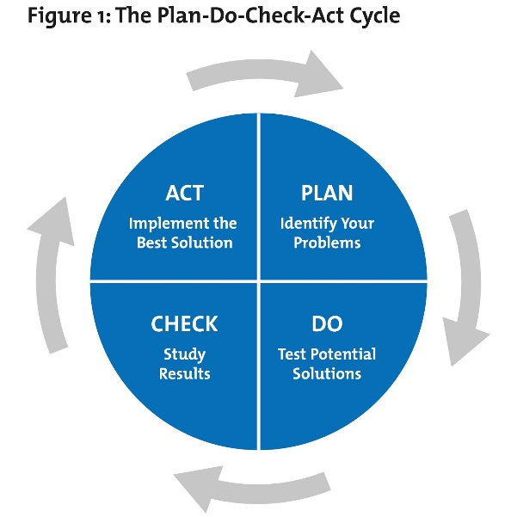

* + 1. Plan – a related series of activities directed toward accomplishing a specific goal
    2. Do – measurement of function/process results, which is used to assess performance of data over a period of time
    3. Check – data-based process of identifying opportunities for improvement and setting priorities
    4. Act - implementation of solutions and interventions based on the set priorities including standardization and placing control systems to avoid deviation
  1. **Performance Improvement Process**

The department has adopted the PDCA Framework as the model for improving performance, and meeting the needs and expectations of the City Agriculturist’s Office.

The framework integrates three core components that offer a broad perspective on improvement: (1) the external environment or those factors affecting how the organization designs its services; (2) the internal environment or those functions and systems within the organization; and (3) cycle for improving performance.

* 1. **Process Map**

One of the developmental goals of Butuan City is to become a ***Robust Industry and Tourism, Competitive Local Economy and Sustainable Agriculture and Fishery Sector***. In support to the city’s developmental goal, the Agricultural and Fishery Sector together with the City Agriculturist Office is purposive in executing all its major final outputs towards the following outcome;

* Transform farmers and fisherfolk to become agri-entrepreneurs,
* Attain food security, and
* Spur agro-industrial development.

the following macro level illustration of business processes are presented as:

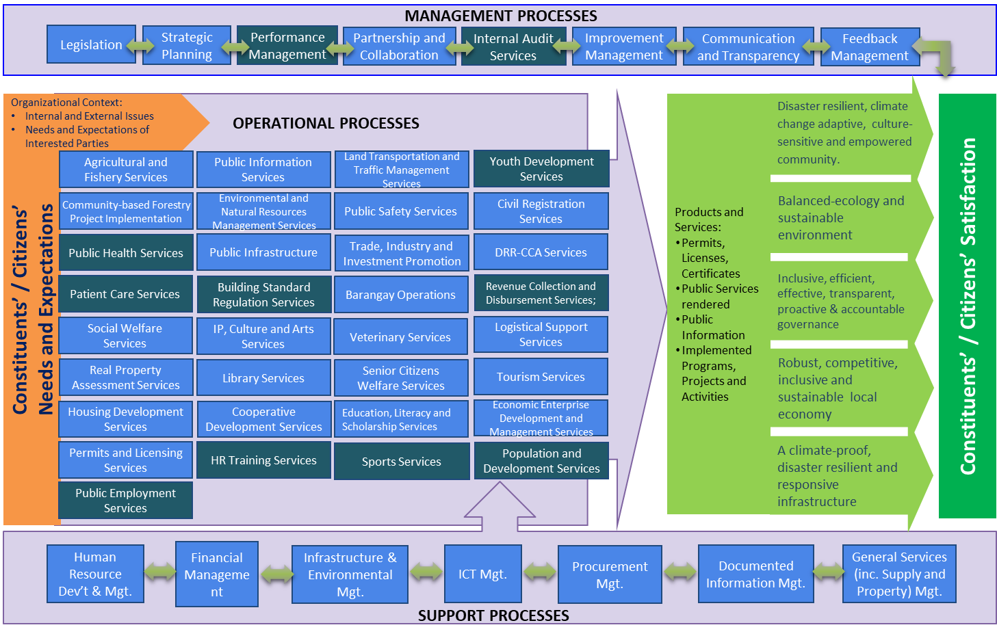

* 1. **Quality Programs, Activities, Education and Training**

The following training and learning interventions have to be attended by all administrative and technical staff and the partners in service excellence:

* + 1. ISO QMS 9001:2015 Orientation

This is to grasp and appreciate the significance of certification in ISO QMS and how it applies in the respective functions and processes in our office. Aside from this, through compliance with ISO 9001: 2015 QMS, CAgrO will be able to enhance efficiency, productivity, responsiveness and transparency. This will also ensure capability in achieving targets and delivery of quality public service to the sector it serves which is the agricultural sector.

* + 1. 5S Orientation

The 5S program in workplace organization method that uses the five phases (Sort, Systematize, Sweep Sanitize and Self-discipline) on how to organize a work space for efficiency and effectiveness. The continuous practice of 5s in the workplace will lead to continuous improvement at the operation level. In addition, implementation of 5s will make work more efficient, increase safety of the workers and improve the quality of work and output. It will also set valuable standards in the office for easy retrieval of documents. Training and learning intervention.

* 1. **Implementation of the Quality Management and Improvement Plan**

1. **CORE PROCESSES AND POLICIES**

The … Policies and Quality Procedures with interfacing relevant forms, aiming at organizational changes for improved service delivery and assist the ... get through present-day operational challenges; categorized into:

* 1. **Agri-Research and Technology Division**
     1. **Procedure on Rice Research and Development of Butuan City Rice Research(BCRRC) on Organic Rice Seed Production**
     2. Procedure of Butuan City Rice Research (BCRRC) on Organic Agriculture Development Program Services
     3. **PROCEDURE ON THE ENROLMENT OF TRAINEES AND CONDUCT OF SKILLS TRAINING**
     4. **PROCEDURE ON THE SUSTAINABILITY OF THE TECHNOLOGY DEMONSTRATION PROJECT**
     5. Procedure on the Operation of City Swine Breeder Farm
  2. **Agro-Industrial Planning and Development Division**
     1. PROCEDURE ON THE PREPARATION OF TECHNICAL DOCUMENTS SUCH AS ACTIVITY DESIGN, PROJECT PROPOSALS AND FEASIBILITY STUDIES
     2. Agro-industrial Development Services Procedure (Submission of Pre-Feasibility Study, Submission of Business Plan, and Submission of Investment Plan)
  3. **Agri-Resource and Investment Management Division**
     1. Procedure on Agri-Resource Investment and Management
     2. Accessed to Finance and Marketing Support Services Procedure
  4. **Operations Management Division**
     1. **Procedure on Organic Agricultural Development Program Services on Establishment of Naturally Grown areas and establishment of Learning Sites**
     2. **Procedure on Rice Research and Development on Organic Seed Production**
     3. Procedure on Rice Technology Demonstration and Farm Machinery Operation
     4. Procedure on Technology Management Services on the Availment of High Value Crop Seedlings and other Produce

**7.10.4 PROCEDURE ON THE AVAILMENT OF PRODUCTION SUPPORT SERVICES SUCH AS SEEDS, SEEDLING, FERTILIZERS AND OTHERS FARM INPUTS**

**7.10.3 PROCEDURE ON APPLYING FOR LAND RECLASSIFICATION AND CONVERSION**

**7.10.**

**7.10.5 PROCEDURE ON THE AVAILMENT OF AGRICULTURAL MACHINERY, EQUIPMENT & POST-HARVEST FACILITIES SUPPORT SERVICES**

**7.10.6 PROCEDURE ON THE AVAILMENT OF LEARNING DEVELOPMENT SERVICES**

**( TRAINING AND SEMINARS)**

* + 1. Procedure on Aquaculture Development Program Services (Fish Sanctuary Development , Mariculture Park Establishment and Operationalization of Freshwater Hatching Facility)

7.10.8 Procedure on Rural-based Organization (RBOs) Capacity Development Services

Details of the above-listed Policy or Quality Procedure are presented in the following Annexes:

|  |  |  |
| --- | --- | --- |
| **Policy/Procedure** | **Document Code** | **Annex** |
| * + 1. **Procedure on Rice Research and Development of Butuan City Rice Research(BCRRC) on Organic Rice Seed Production** | CAgrO.PR.001.REV00 |  |
| * + 1. Procedure of Butuan City Rice Research (BCRRC) on Organic Agriculture Development Program Services | CAgrO.PR.002.REV00 |  |
| * + 1. **PROCEDURE ON THE ENROLMENT OF TRAINEES AND CONDUCT OF SKILLS TRAINING** | CAgrO.PR.003.REV00 |  |
| * + 1. **PROCEDURE ON THE SUSTAINABILITY OF THE TECHNOLOGY DEMONSTRATION PROJECT** | CAgrO.PR.004.REV00 |  |
| * + 1. Procedure on the Operation of City Swine Breeder Farm | CAgrO.PR.004.REV00 |  |
| * + 1. PROCEDURE ON THE PREPARATION OF TECHNICAL DOCUMENTS SUCH AS ACTIVITY DESIGN, PROJECT PROPOSALS AND FEASIBILITY STUDIES | CGB.CAgrO.PR.001.REV00 |  |
| * + 1. Agro-industrial Development Services Procedure (Submission of Pre-Feasibility Study, Submission of Business Plan, and Submission of Investment Plan) | CGB.CAgrO.PR.002.REV00 |  |
| * + 1. Procedure on Agri-Resource Investment and Management | CGB.CAgrO.PR.003.REV00 |  |
| * + 1. Accessed to Finance and Marketing Support Services Procedure | CGB.CAgrO.PR.004REV00 |  |
| * + 1. **Procedure on Organic Agricultural Development Program Services on Establishment of Naturally Grown areas and establishment of Learning Sites**   **7.10.4**  **7.10.3** | CAgrO.PR.005.REV00 |  |
| * + 1. **Procedure on Rice Research and Development on Organic Seed Production** | CAgrO.PR.006.REV00 |  |
| * + 1. Procedure on Rice Technology Demonstration and Farm Machinery Operation | CAgrO.PR.007.REV00 |  |
| * + 1. Procedure on Technology Management Services on the Availment of High Value Crop Seedlings and other Produce | CAgrO.PR.008.REV00 |  |
| **PROCEDURE ON THE AVAILMENT OF PRODUCTION SUPPORT SERVICES SUCH AS SEEDS, SEEDLING, FERTILIZERS AND OTHERS FARM INPUTS** | CAgrO.PR.009.REV00 |  |
| **PROCEDURE ON APPLYING FOR LAND RECLASSIFICATION AND CONVERSION** | CGB.CAgrO.PR.005.REV00 |  |
| **PROCEDURE ON THE AVAILMENT OF LEARNING DEVELOPMENT SERVICES**  **( TRAINING AND SEMINARS)**  7.10.8 | CAgrO.PR.010.REV00 |  |
| * + 1. Procedure on Aquaculture Development Program Services (Fish Sanctuary Development , Mariculture Park Establishment and Operationalization of Freshwater Hatching Facility) | CAgrO.PR.011.REV00 |  |
| Procedure on Rural-based Organization (RBOs) Capacity Development Services | CAgrO.PR.012.REV00 |  |

1. **IMPLEMENTATION OF THE MANUAL**
   1. **Amendments and Additions**

Any amendment or additions to this Operations Manual (OM) or its portions, with the introduction of change in the service, process, or a change in organizational structure, shall be allowed if deemed necessary to provide flexibility to the continuous quality improvement mandate of the City Agriculturists Office in meeting the constantly changing stakeholders requirements. Recommendation of change/s shall be communicated in writing to the ….. for evaluation and endorsement for approval to the …...

Effectivity of amendment/s or addition/s shall take effect upon re-issue of the Notice of Change bearing the complete section or subsection as identified in the amendment to the document.

* 1. **Document Maintenance**

The QMS Focal Person shall be responsible for the maintenance and validity of the Operations Manual. The Document Controller (DC) shall ensure that all officially issued and controlled copies of the Manual and any subsidiary documents (including copies of parts of the OM) are updated and re-issued incorporating any changes at prescribed intervals of not greater than a calendar year.

* 1. **Distribution**

Distribution of the Manual through the Division Heads shall be facilitated by the Document Controller (DC).

* 1. **Approval**

This Operations Manual (OM) shall be endorsed to the ... upon approval of the …